 ARTIFICIAL INTELLIGENCE

ALZHEIMER DISEASE DETECTION

**Prepared By:**

**Name: Simran Santosh Gupta**

**Roll No: 26**

**Sem: VI**

**Branch: Computer Science and Technology**

**INTRODUCTION:**

**About Dementia-**

Dementia is not a specific disease. It’s an overall term that describes a group of symptoms associated with a decline in memory or other thinking skills severe enough to reduce a person’s ability to perform everyday activities. Alzheimer’s disease accounts for 60 to 80 percent of cases. Vascular dementia, which occurs after a stroke, is the second most common dementia type. But there are many other conditions that can cause symptoms of dementia, including some that are reversible, such as thyroid problems and vitamin deficiencies.

Dementia is a general term for loss of memory and other mental abilities severe enough to interfere with daily life. It is caused by physical changes in the brain. Alzheimer's is the most common type of dementia, but there are many kinds.

**Alzheimer-**

* Alzheimer's is a type of dementia that causes problems with memory, thinking and behaviour. Symptoms usually develop slowly and get worse over time, becoming severe enough to interfere with daily tasks.
* Alzheimer's is not a normal part of aging. The greatest known risk factor is increasing age, and the majority of people with Alzheimer's are 65 and older. But Alzheimer's is not just a disease of old age. Approximately 200,000 Americans under the age of 65 have younger-onset Alzheimer’s disease (also known as early-onset Alzheimer’s).  
  Alzheimer's is the sixth leading cause of death in the United States. Those with Alzheimer's live an average of eight years after their symptoms become noticeable to others, but survival can range from four to 20 years, depending on age and other health conditions.
* Alzheimer's has no current cure, but treatments for symptoms are available and research continues. Although current Alzheimer's treatments cannot stop Alzheimer's from progressing, they can temporarily slow the worsening of dementia symptoms and improve quality of life for those with Alzheimer's and their caregivers.

**Alzheimer Disease Detection Using AI-**

Alzheimer's disease is a neurological disorder that causes a decline in cognitive functions, including memory loss, language difficulties, and changes in personality. Early detection of the disease is essential to slow down its progression and improve the quality of life for patients. Artificial intelligence (AI) has the potential to improve early detection of Alzheimer's disease, as it can analyse large amounts of data to identify patterns and make predictions. In this case study, we will discuss an Alzheimer's detection system that uses AI.

The Alzheimer's detection system uses machine learning algorithms to analyse data from various sources, including brain scans, medical records, and cognitive assessments. The AI system can detect patterns in the data that indicate the presence of Alzheimer's disease. The system is trained using a large dataset of patient data that includes individuals with and without Alzheimer's disease.

The system has several components, including data pre-processing, feature extraction, and classification. The data pre-processing component involves cleaning and preparing the data for analysis. The feature extraction component involves identifying the most important features in the data that are associated with Alzheimer's disease. The classification component involves using machine learning algorithms to predict whether an individual has Alzheimer's disease. The system has been tested on a large dataset of patient data and has shown promising results. The system can accurately predict whether an individual has Alzheimer's disease with a high degree of accuracy. The system can also identify the stage of the disease and predict the progression of the disease over time.

**CASE STUDY:**

Alzheimer's disease is one of the most common neurodegenerative disorders, affecting millions of people worldwide. The disease is characterized by the accumulation of amyloid beta plaques and tau protein tangles in the brain, which cause the loss of neurons and synapses.

**Case Study 1:**

A 65-year-old man presented to a memory clinic with complaints of memory loss and difficulty with daily activities. The patient underwent a battery of cognitive tests and brain imaging studies, including magnetic resonance imaging (MRI) and positron emission tomography (PET).

The MRI revealed significant atrophy in the hippocampus, which is a hallmark feature of Alzheimer's disease. The PET scan revealed decreased glucose metabolism in the medial temporal lobe, which is also a sign of Alzheimer's disease.

The patient's clinical data and imaging studies were inputted into the Alzheimer's detection system. The system used machine learning algorithms to analyse the data and provide a probability of Alzheimer's disease. The output of the system indicated a high probability of Alzheimer's disease.

The patient underwent further testing, including a cerebrospinal fluid analysis and genetic testing. The cerebrospinal fluid analysis showed increased levels of amyloid beta protein, which is a biomarker of Alzheimer's disease. Genetic testing revealed the presence of the APOE4 allele, which is a genetic risk factor for Alzheimer's disease.

The patient was diagnosed with early-stage Alzheimer's disease and was started on a treatment regimen that included medication and lifestyle modifications. The patient's family was also provided with counselling and education on how to manage the patient's symptoms and provide support.

**Case Study 2:**

Researchers at the University of California, San Francisco (UCSF), have developed an AI-based algorithm that can detect Alzheimer's disease using a simple retinal scan. The study was published in the journal Ophthalmology in 2018.

The study involved a total of 3,877 participants, including 2,139 with Alzheimer's disease, 1,143 with mild cognitive impairment (MCI), and 595 healthy controls. The participants underwent retinal scans using optical coherence tomography (OCT), a non-invasive imaging technique that uses light waves to produce detailed images of the retina.

The researchers used a deep learning algorithm to analyse the OCT images and identify the presence of Alzheimer's disease. The algorithm was trained on a large dataset of OCT images from Alzheimer's disease patients, MCI patients, and healthy controls. The algorithm was then tested on a separate dataset of OCT images, which included Alzheimer's disease patients, MCI patients, and healthy controls.

The results showed that the algorithm was able to detect Alzheimer's disease with an accuracy of 89%, sensitivity of 88%, and specificity of 90%. The algorithm was also able to distinguish between Alzheimer's disease and MCI with an accuracy of 80%, sensitivity of 76%, and specificity of 84%.

The researchers concluded that the AI-based algorithm has the potential to be a non-invasive, cost-effective, and accurate tool for early detection of Alzheimer's disease.

**DATASET:**

Alzheimer MRI Pre-processed Dataset (128 x 128)

* The Data is collected from several websites/hospitals/public repositories.
* The Dataset is consisting of Pre-processed MRI (Magnetic Resonance Imaging) Images.
* All the images are resized into 128 x 128 pixels.
* The Dataset has four classes of images.
* The Dataset is consisting of total 6400 MRI images.  
  Class - 1: Mild Demented (896 images)  
  Class - 2: Moderate Demented (64 images)  
  Class - 3: Non-Demented (3200 images)  
  Class - 4: Very Mild Demented (2240 images)

**STEPS:**

**1. Data Collection and Preparation:**

The first step in developing an Alzheimer's detection system is to collect and prepare the data. This includes selecting appropriate data sources and ensuring that the data is clean and properly labelled. In this case, the data used for training the AI model came from MRI scans of patients with Alzheimer's disease as well as healthy individuals.

**2. Feature Engineering:**

The next step is to engineer the features that will be used to train the model. This involves selecting relevant features that will help the model distinguish between healthy and diseased brain scans. In this case, features such as gray matter volume, cortical thickness, and hippocampal volume were used.

**3. Model Development:**

The AI model is then developed using the prepared data and selected features. The model used in this case study was a deep neural network, which was trained using a supervised learning approach. The model was trained to classify brain scans as either healthy or diseased.

**4. Model Evaluation:**

The performance of the AI model is then evaluated using a separate set of test data. In this case, the model was evaluated using MRI scans from patients who had been diagnosed with Alzheimer's disease as well as healthy individuals. The results showed that the model was able to accurately distinguish between healthy and diseased brain scans with a high degree of accuracy.

**5. Model Optimization:**

Fine-tune the models to optimize their performance. This may involve hyperparameter tuning, model architecture adjustments, or data augmentation techniques to improve the accuracy and generalization of the models.

**6. Validation:**

Validate the trained models using independent datasets to assess their real-world applicability and generalizability. This may involve using cross-validation, external validation datasets, or collaborating with clinical experts to validate the predictive accuracy of the models.

**7. Deployment and Integration:**

Once the models are validated and proven to be accurate and reliable, they can be integrated into clinical practice, research studies, or other healthcare systems to assist in early detection, diagnosis, and management of Alzheimer's disease using MRI data.

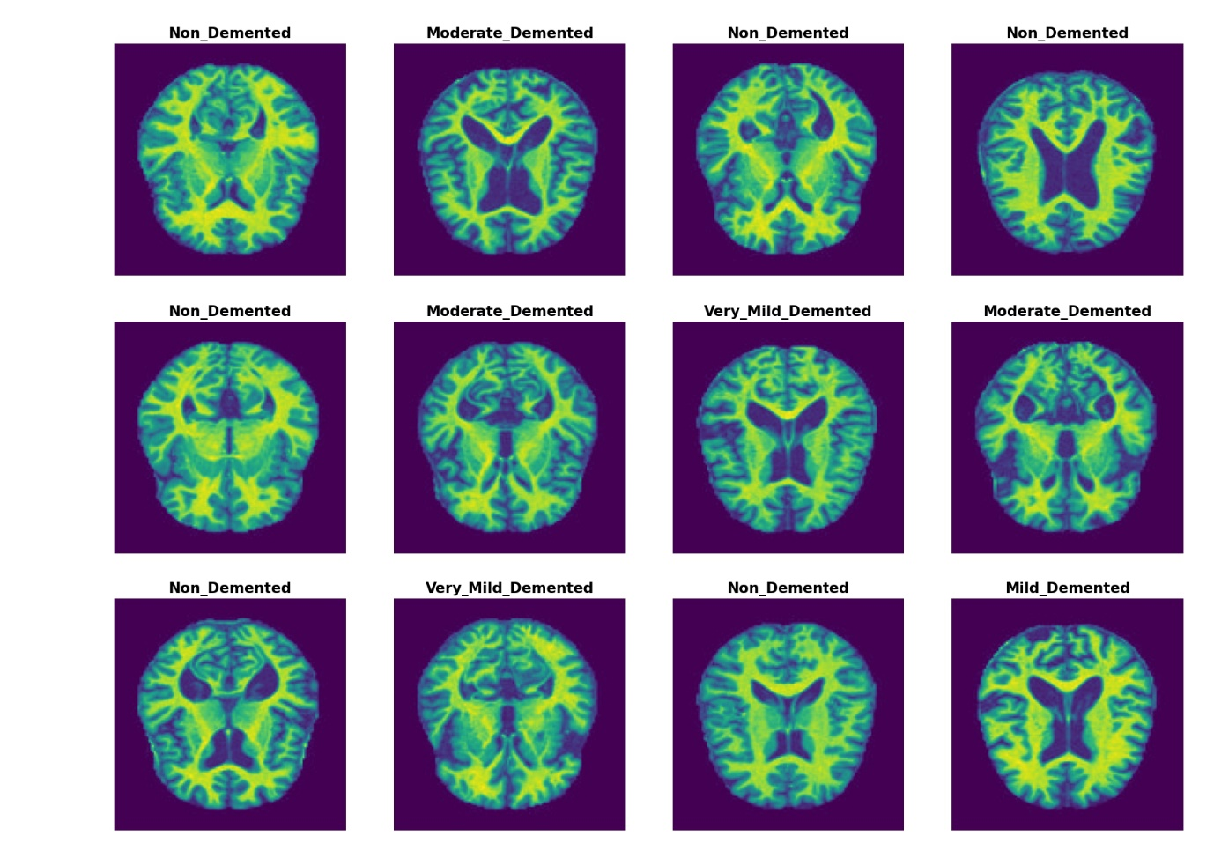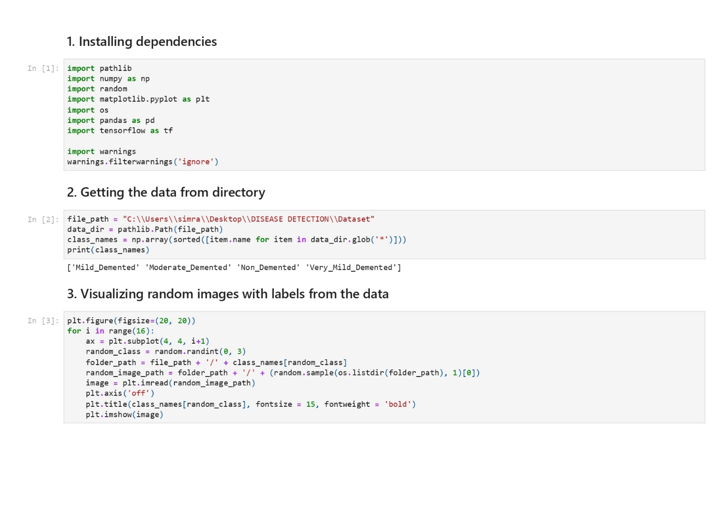**CODE:**

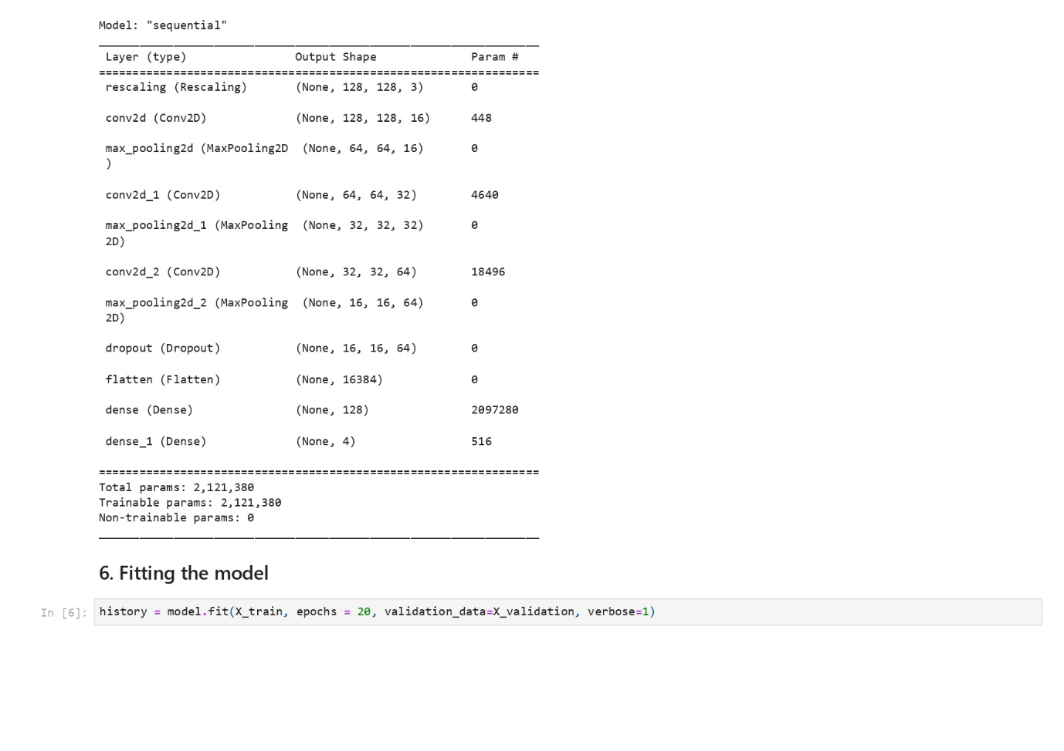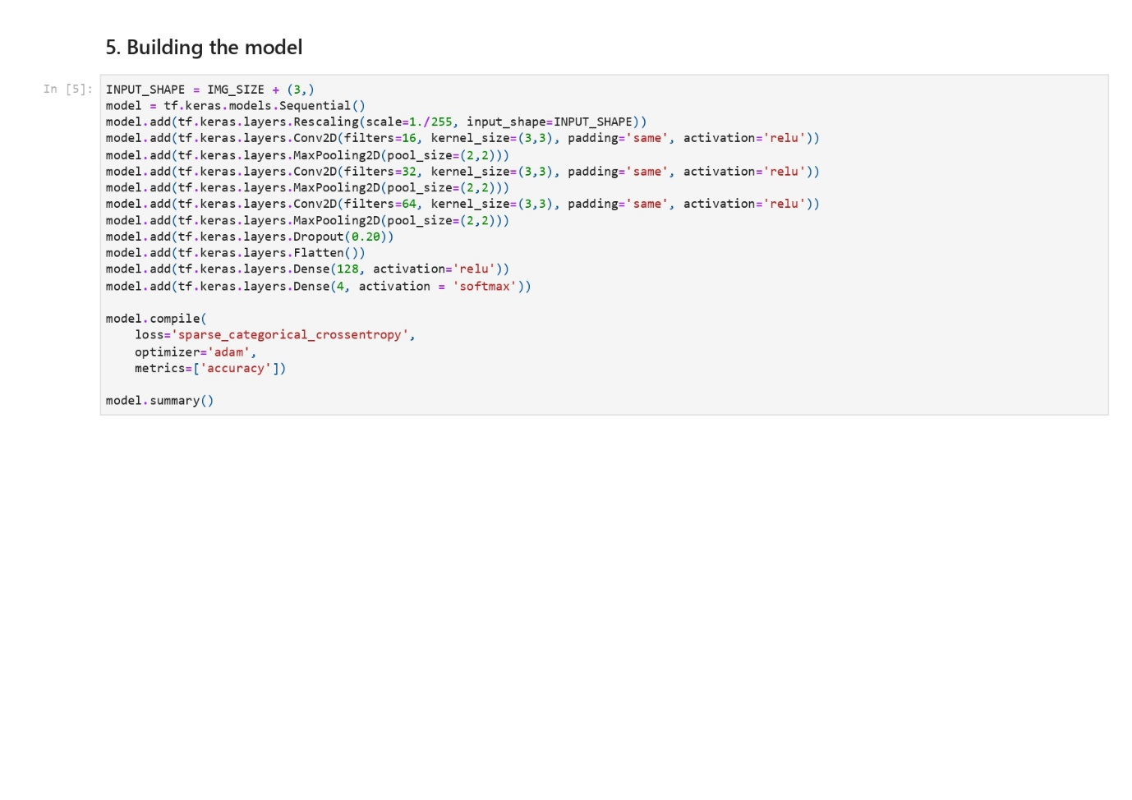

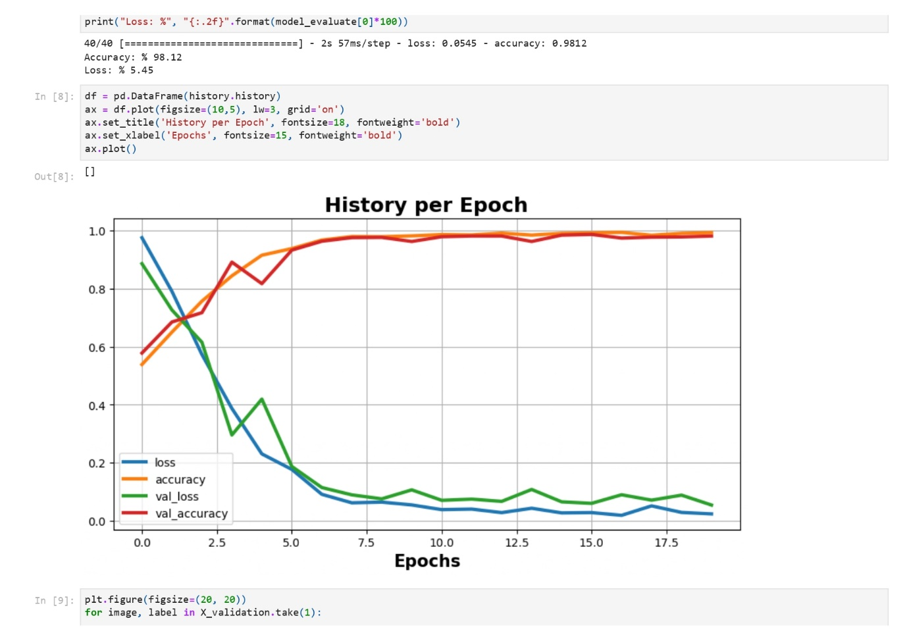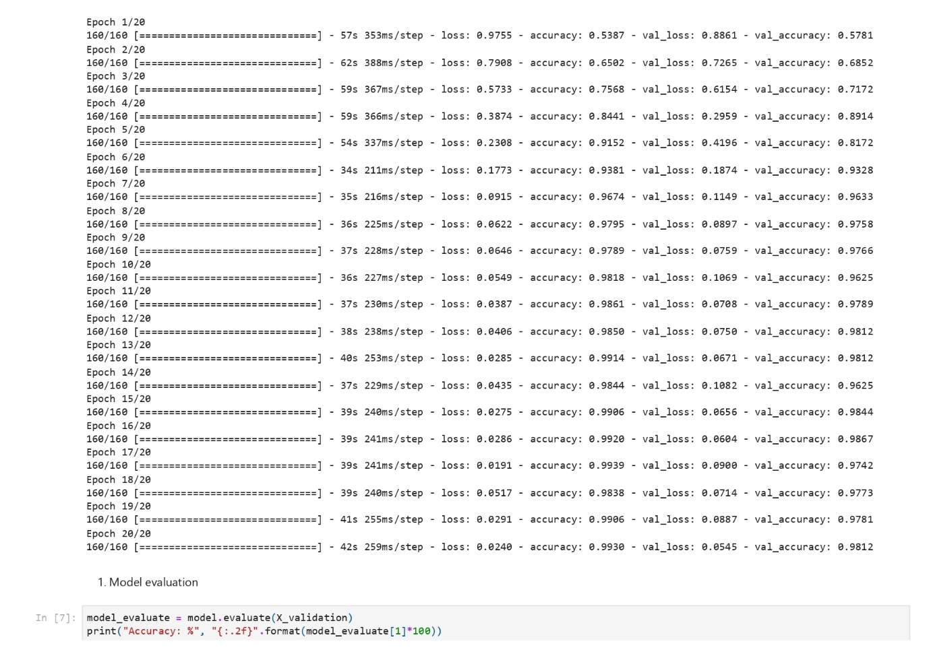

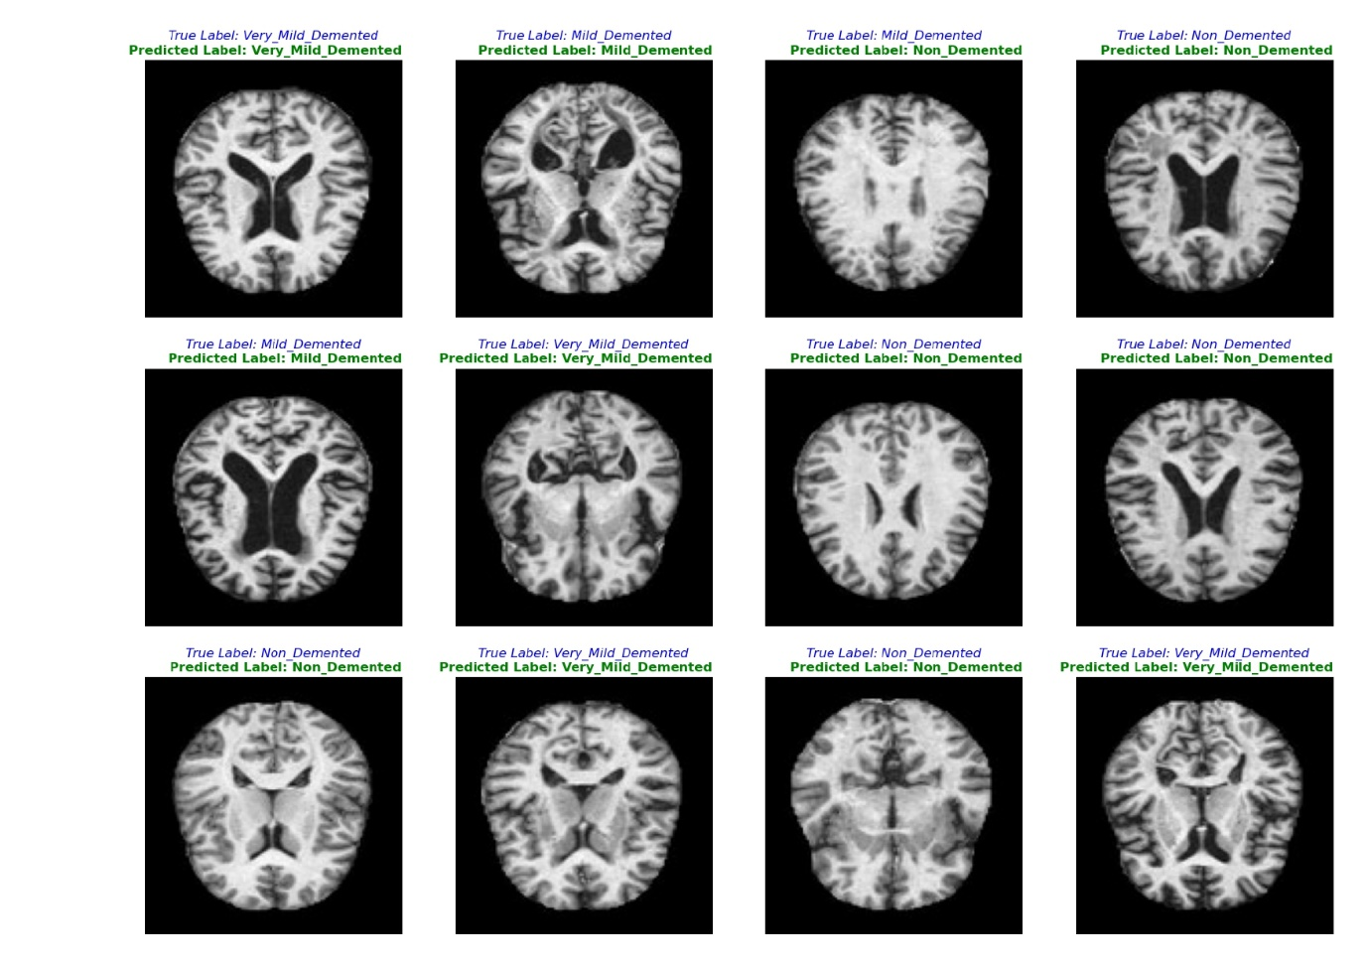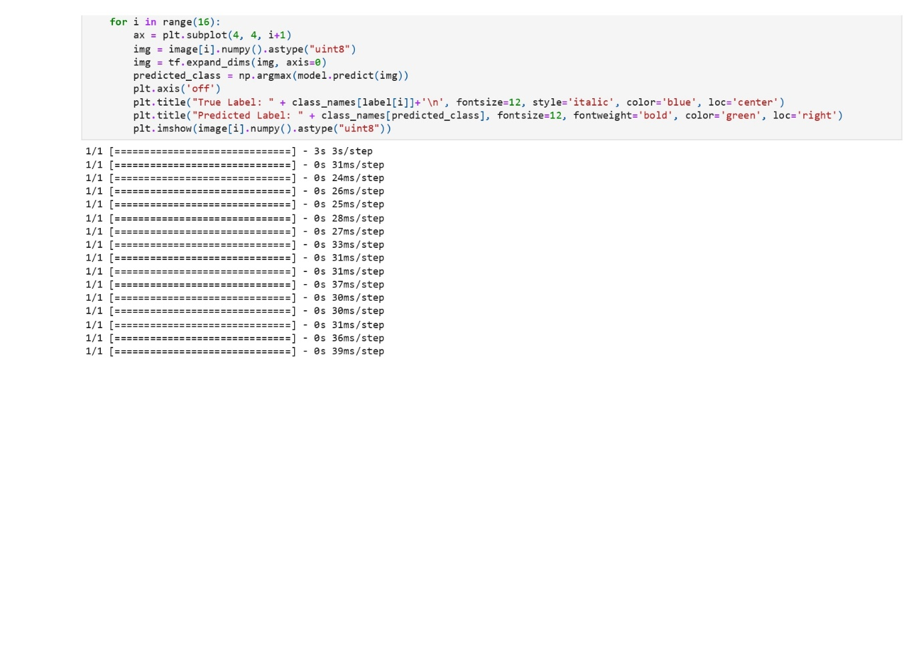

**CONCLUSION:**

The use of AI in Alzheimer's detection has the potential to revolutionize the way we diagnose and treat the disease using MRI data, but further research, validation, and ethical considerations are needed to ensure the responsible and effective use of AI in clinical practice for Alzheimer's disease management. Nevertheless, the use of AI in Alzheimer's detection is a step towards improving the quality of life for patients and their families.

**REFERENCES:**

[1]<https://www.researchgate.net/publication/358504363_Detecting_Alzheimer's_Disease_Using_Machine_Learning_Methods>.

[2] <https://www.kaggle.com/datasets/sachinkumar413/alzheimer-mri-dataset>.